Additional costs of living for people who are sight impaired or severely sight impaired

Research Findings 51

Published by Thomas Pocklington Trust
January 2016
www.pocklington-trust.org.uk

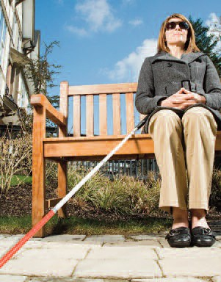
This publication summarises findings from research commissioned by Thomas Pocklington Trust and conducted by Katherine Hill, Lydia Marshall, Donald Hirsh and Matt Padley, at the Centre for Research in Social Policy, Loughborough University.

The research used an established methodology that defines Minimum Income Standards (MIS) for different households to consider how much more it costs, as a minimum, to live with different degrees of sight loss at different times of life.

It established minimum weekly budgets for:
- a working age person who is eligible for certification as severely sight impaired;
- a pension age person who is eligible for certification as sight impaired and has acquired their sight loss as an adult.

Summary findings
- The additional cost of living with sight loss varies significantly with the severity of impairment and stage of life at which it is experienced.
- The budget for a working age person living alone who is eligible for certification as severely sight impaired with little or no sight is 60% more than for someone without that impairment: £116 extra on top of the minimum income standard of £195 a week. This is more than double the additional £49 a week identified in a previous study for a working age person who is eligible for certification as sight impaired and has some usable sight. Having a Guide Dog adds an extra £16 a week to minimum costs for someone who is severely sight impaired, and being a Braille user adds £6.
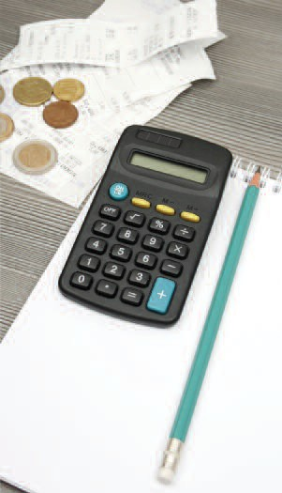
- The budget for someone of pension age who is living alone and is eligible for certification as sight impaired and has some usable sight is 41% more than for someone without that impairment: £75 extra on top of the minimum income standard of £182 a week. This is 50% more than the additional cost (£49 a week) for someone of working age with the same degree of sight loss.
- Having a more severe sight impairment brings the greatest additional costs in five main areas of life: extra domestic help, travel, technology, social activities and food.
- For someone who is eligible for certification as sight impaired being of pension age makes the most difference to the budget for household services and travel costs.
- For someone of working age who is eligible for certification as severely sight impaired and with no usable sight, the overall minimum budget is slightly reduced (by £5 per week) because some aids and goods that assist sight are not relevant.
- Underlying these variations in costs is the interaction of a range of practical and psychological factors, e.g. the ability and confidence to do domestic tasks such as cleaning and to take public transport. The amount of help available from friends and relations, the strength of local services, and interactions between sight loss and other impairments are also all important in determining additional costs.
- People of working age who are severely sight impaired and people over pension age who are sight impaired may be eligible for some help from Personal Independence Payments or Attendance Allowance. However, higher or enhanced benefit levels are required in order to come close to, or cover the additional costs identified in this study.

Background and context
This research applied the Minimum Income Standard (MIS) approach to people who are vision impaired. MIS is an ongoing programme of research that calculates the cost of a minimum standard of living for different households, by asking groups of members of the public to identify detailed lists of items that people need in order to reach a minimum acceptable standard of living in the United Kingdom today.

An initial study, funded by Thomas Pocklington Trust and carried out in 2014, used the MIS method to identify additional costs of living for people who are sight impaired. Building on MIS budgets for households without vision impairment, that research explored additional requirements and costs for the case of a single working age adult who is eligible for certification as sight impaired.

A second study, reported on here, extends that research to consider:
- the effect of the severity of impairment, by looking at additional costs for a working age person who is severely sight impaired;
- demographic difference, by considering a pension age person who is sight impaired (and has acquired sight loss as an adult).

This further study of the cost of vision impairment was designed both to look at the needs associated with the new cases in their own right and to yield insights into how needs change with the degree of impairment and life stage.

Research methods
The research involved asking three groups of working age people who are severely sight impaired, and three groups of pension age people who are sight impaired about the additional things that a single person with vision impairment similar to their own would require for a minimum standard of living. For the severely sight impaired case, it was specified that the person has little or no sight, but groups also considered certain instances where the following variations within this category could make a difference to costs:
- having no vision at all compared to some very limited sight;
- using Braille;
- being a Guide Dog user.
Participants discussed in detail what goods and services would need to be different to those in the MIS budgets for a sighted person, because someone has vision impairment. These requirements were costed to create an additional budget for each case under consideration compared to the main MIS budgets for a sighted person. The additional needs and costs of each case were also compared to the budget created for the working age sight impaired case in the previous study.

Findings

The size of additional costs and where they fall.
The groups identified additional needs and costs across a range of categories for a sight impaired person of pension age and a severely sight impaired person of working age as compared to a fully sighted person. The resulting additional costs were then compared to those identified for a sight impaired person of working age in the earlier study.

The figures below show the additional costs per week for each group when compared to the established weekly minimum budget for a fully sighted person. Please note that some of the figures have been rounded.

Household services
- Sight impaired working age adult (previous research) £13.46
- Severely sight impaired working age adult: £30.71
- Sight impaired pension age adult: £26.32
Quote from participant: “Crumbs under the settee which you haven’t noticed and a cobweb in the corner, you can’t see that whereas a cleaner has got better eyesight.”
All groups identified an additional need for help with services in the home, especially regular cleaning, which fully sighted people do not consider part of an essential minimum. They felt that although vision impairment does not stop you from looking after your home, additional help can provide reassurance that it is kept at a reasonable standard of cleanliness, and included the cost of a cleaner for two hours a fortnight. Severely sight impaired adults of working age and sight impaired pensioners also identified a need for additional help above that required by sight impaired working age people. This included an additional ‘deep clean’ or help with larger tasks from time to time.

Both of these groups also identified a need for help with paperwork, with an hour a week formal support added to the working age severely sight impaired budget and an amount included in the pension age sight impaired budget to recognise informal support provided by family or friends. They also thought that additional help with home maintenance would be needed, with the pension age groups emphasising that the combination of sight impairment and physical deterioration could result in a need for extra help around the home with heavy jobs.

Transport and travel
- Sight impaired working age adult (previous research) £6.50
- Severely sight impaired working age adult: £27.50
- Sight impaired pension age adult £24.17

A greater need for taxis accounts for much of the increase in transport budgets for people who are vision impaired. Both of the groups consulted for this research project identified greater additional transport costs than those for sight impaired adults of working age. For both severely sight impaired working age people and sight impaired pensioners, taking public transport can be difficult, for example at night and on unfamiliar routes, and so more frequent taxi travel is identified as a minimum need. Both groups also identified an additional need for taxi journeys relating specifically to sight loss, such as attending hospital appointments or support groups.

Social activities
- Sight impaired working age adult (previous research): £8.98
- Severely sight impaired working age adult: £19.28
- Sight impaired pension age adult: £5.91

Groups in both the current and previous studies stressed the danger of isolation for people who are vision impaired, and emphasised the importance of social interaction. Associated with the importance placed on social interaction were additional costs such as showing reciprocity to someone who accompanies them on trips for social purposes, such as buying them a meal. The budget for someone with severe sight impairment was further increased to allow for more and specialist activities. The budget for a holiday was also increased for both the sight impaired and severely sight impaired working age groups to allow for an alternative to the self catering model which is considered a minimum for sighted people of working age.

Technology
- Sight impaired working age adult (previous research): £12.82
- Severely sight impaired working age adult: £18.11
- Sight impaired pension age adult: £6.21

The use of mobile phones and computers to help address the consequences of sight loss is important to working age groups in both this and the previous research, and in particular to those with severe sight impairment. Both working age groups amended the budgets for people with vision impairment to include an iPhone because of useful features such as magnification and screen reader.

However, the additional cost of this phone is greater in the severely sight impaired budget due to the higher specification package and the more frequent replacement required to meet the heavier use made of the device. Similarly, a higher specification of computer and software was deemed necessary by those in the working age severely sight impaired groups.

In comparison, the budget for a sight impaired pensioner includes less use of technology. For example, this group specified an easier to use standard mobile rather than an iPhone and did not upgrade the computer or add assistive software. However, they still identified additional costs for portable static magnifiers.

Food and drink
- Sight impaired working age adult (previous research): no additional costs identified
- Severely sight impaired working age adult: £9.23
- Sight impaired pension age adult: £5.70
Quote from participant “When you go shopping, you've got to get the shopping home, you've got to have some support to label it and it’s much easier to label a ready meal.”
Both severely sight impaired people of working age and sight impaired pensioners said that while people with these impairments are able to prepare food, it can be difficult and time-consuming to do so, and as a consequence some budget for ready meals is appropriate. This created additional food costs compared to a sighted person, which had not been seen as necessary for a sight impaired working age person in the previous study.

Other costs

Personal goods and services
- Sight impaired working age adult (previous research): £3.27
- Severely sight impaired working age adult: £6.91
- Sight impaired pension age adult: £2.04

Household fittings and furnishings
- Sight impaired working age adult (previous research): £3.18
- Severely sight impaired working age adult: £3.96
- Sight impaired pension age adult: £4.73

Household bills
- Sight impaired working age adult (previous research): £0.56
- Severely sight impaired working age adult: £0.73
- Sight impaired pension age adult: £0.32

The study identified a range of other needs bringing smaller additional costs. Severely sight impaired people need to spend more on sturdier footwear and replacing some clothes. Vision impaired people in all categories emphasised the need for additional lighting in the home, but this does not bring very different costs related to severity (unless someone has no sight) or life stage. Similarly, other additional costs identified in this study, covering items such as security in the home and additional electricity to power stronger lighting, are not very different from those identified in the previous study.
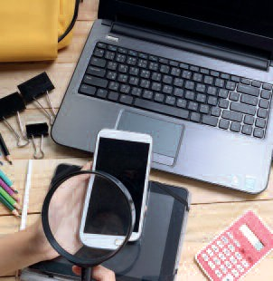
For Braille users, additional equipment adds £6 to a weekly budget and for Guide Dog owners, £16 extra is mainly attributable to additional cleaning. Severely sight impaired people with no sight have slightly fewer additional costs (£5 less a week) than those who are severely sight impaired with a little sight, mainly because of the lack of requirement to spend so much on spectacles, specialist lighting or a large computer screen.

Conclusions and policy implications
Total additional costs per week compared to MIS budgets for a sighted person:
- Sight impaired working age adult (previous research): £48.77
- Severely sight impaired working age adult: £116.43
- Sight impaired pension age adult: £75.39

This research builds on the findings of the previous study showing that people who are vision impaired face a range of additional household costs, but also shows how these costs can vary greatly according to severity of impairment and life stage. In particular, having a severe sight impairment more than doubles the additional costs identified for someone of working age who is sight impaired but with some usable sight. Being of pension age and sight impaired adds around 50 per cent more costs than at working age with the same level of impairment.

Behind these differences lie both practical considerations and psychological factors that influence what people who are vision impaired require in order to participate fully in society. These factors interact to influence, in particular:
- how much help people need in the home;
- how they can stay safe;
- the help and support that they require outside the home including in getting around and in participating socially;
- how they use technology.

The benefits system recognises extra costs associated with disability but takes a narrower view of how they arise than implied by this research – relating to specific things people can and cannot do rather than to the ways in which disabled people live their lives, and how this influences costs. Severely sight impaired people of working age and sight impaired pensioners may be eligible for some help from Personal Independence Payments or Attendance Allowance. However, these benefits will only come close to, or cover, the additional costs identified in this study if an award is made at the higher or enhanced benefit level.

Authors
Katherine Hill, Lydia Marshall, Donald Hirsch and Matt Padley

The status of this research
The research reported here is independent research commissioned by Thomas Pocklington Trust. The views expressed in this publication are those of the authors and not necessarily those of Thomas Pocklington Trust.

In this publication, the terms ‘people who are vision impaired’ and
‘people with sight loss’ all refer to people who are eligible for
certification as either sight impaired (partially sighted) or severely
sight impaired (blind).

How to obtain further information
The full research report sets out the method in more detail, and
describes how groups discussed additional needs and the rationales given for including items in the budgets.
The report: ‘Sight Loss and Minimum Living Standards: The Additional Costs of Living for People of Working Age who are Severely Sight Impaired and for People of Pension Age with Acquired Sight Impairment’ can be obtained from www.crsp.ac.uk/publications

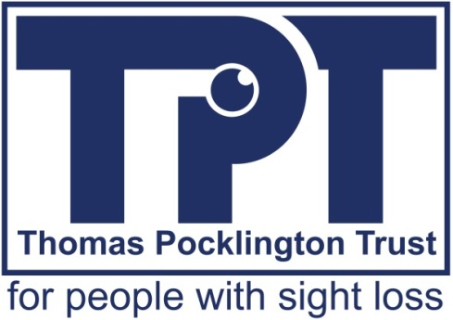

Thomas Pocklington Trust
Tel: 020 8995 0880
Email: research@pocklington-trust.org.uk
Web: www.pocklington-trust.org.uk

Published by Thomas Pocklington Trust
Registered Charity No. 1113729
Company Registered No. 5359336

Research Findings 51

