Age-related macular degeneration (AMD) in Oxfordshire

The STAR Approach

July 2017




By:
Richard Glover, NHS North of England Commissioning Support (NECS)
Anita Lightstone
Fran Ramsay, NHS Thames Valley Eye Health Network



With support from:
Gwyn Bevan, The London School of Economics and Political Science
Susie Downes, NHS Oxford University Hospitals Trust

Funded by:
Thomas Pocklington Trust
The Health Foundation

Comment
It is important for all patients affected by sight loss to receive timely and effective treatment to improve their health outcomes and as part of maintaining their independence. Delays in receiving treatment can impact negatively on these health outcomes and risk further deterioration of an individual’s sight. This report offers practical solutions to improve the way services are managed for the benefit of the patient and for the hospital eye service. We are pleased to note how partnership working across health, local authority and the voluntary sector can be of benefit to patients. While this report focuses on age-related macular degeneration, the learning can be applied to other conditions. We endorse the findings of this report and strongly suggest commissioners of eye health services should take account of these.

Phil Ambler
Research and Policy Director
Thomas Pocklington Trust

The Thames Valley Eye Health Network have been delighted to be part of this rigorous initiative to look at provision of services for wet AMD in Oxfordshire. From statistics in the recent Thames Valley Eye Health Needs Assessment, it is clear that the demand on these services is likely to be exponential over the foreseeable future. Through the well-researched workshops that brought together key stakeholders, including patients, we have been able to highlight several potential areas where change will lead to improvements for all and make maximum use of available resources. Outpatient appointments for ophthalmology in Oxfordshire are rising by at least 10% each year and many of these will be for people with wet AMD. Through the rigour of the STAR approach, we have identified ways to ensure timely diagnosis and intervention for all patients with suspected wet AMD. We look forward to supporting the implementation of these changes.

Fran Ramsay
Chair
Thames Valley Eye Health Network

Contents
Introduction | 5
Executive Summary | 6
What is AMD? | 7
Wet AMD in Oxfordshire | 8
Journey of a wet AMD patient | 9
The cost of treating AMD | 11
And the cost of sight loss | 11
The problem | 13
Challenges facing the NHS | 13
What happens if we don’t change anything? | 14
The STAR approach | 14
The two workshops | 15
Participants | 16
Where to focus | 17
What can we change | 18-19
Who can change | 20
Easy Changes | 21
High Impact Changes | 22-24
Medium & Low Impact Changes | 24-27
Next steps | 28
Glossary | 28

Introduction

This project uses a workshop-based process called the STAR Approach as its focus. STAR was designed by health economists to identify how to get optimal value for money from services provided by health organisations.

The Thomas Pocklington Trust - a charity that works to improve the lives of people with sight loss - was presented with the methodology and thought it could be usefully applied to age-related macular degeneration (AMD). With collaboration from the Thames Valley Local Eye Health Network and local clinicians, Oxfordshire was chosen as an ideal area to implement STAR.

While the STAR Approach was initially created to determine how new funding could be allocated, the economic climate has changed and the methodology is now used to understand how resources can be reallocated to gain better value from current services.

Hospital services are under great pressure and as this pressure increases, so do the delays experienced by patients in accessing the treatment that can prevent deterioration in their condition - in this case sight loss. Staff morale can also be negatively affected and hospitals struggle to meet targets set out by national guidelines.

It is therefore important to think about innovative ways that we can relieve some of the pressure in the system. This process is about bringing people together - from patients to optometrists, hospital staff and managers – and talking about ways that we can make healthcare work more efficiently.

Getting more out of the money we spend ultimately means better health for everyone from the taxes we pay.

Executive Summary

The brief

Use a value-for-money methodology to identify inefficiencies and improvements in care for patients with wet AMD in Oxfordshire.

The process

30 experts in eye health and sight loss from across Oxfordshire came together at two workshops to map local AMD care, identify associated issues and potential solutions. Participants included patients, carers, consultants, community optometrists, among others.

Key findings - Challenges
- Resources at the Oxford Eye Hospital are stretched
- Importance of emotional support and consistent information is underestimated
- Communication among providers of local eyecare, and with local management and commissioners could be improved

Key findings - Solutions
- Move certain services into the community
- Make better use of current services, specifically eye health and sight loss advisers and the voluntary sector
- Further improvements of lower but significant impact were also identified

Outcome

Potential changes have varying levels of feasibility and risk attached, which need to be assessed. Actionable tasks should be allocated an owner and progressed.

What is AMD?

Below is a diagram of the eye, showing the location of the Macula

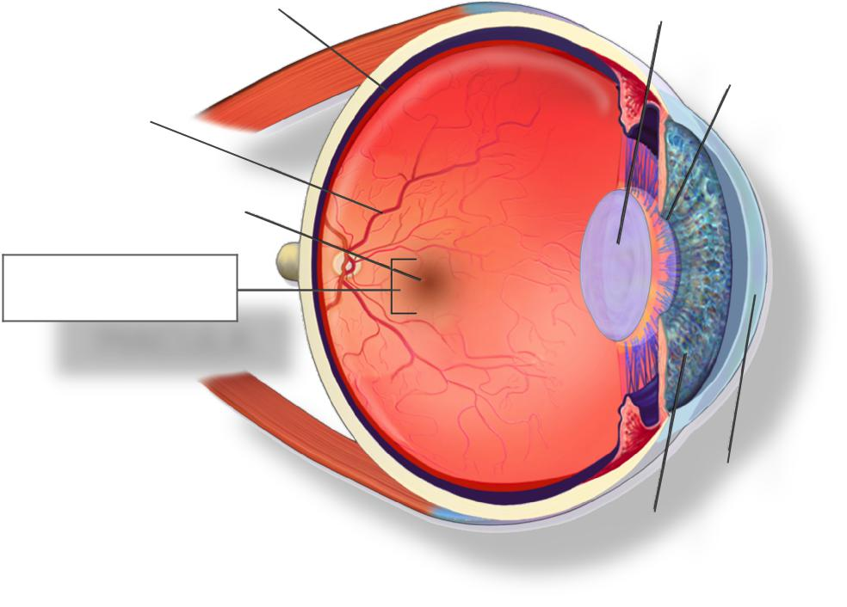
PUPIL
LENS
IRIS
MACULA
FOVEA
BLOOD VESSELS
RETINA
CORNEA

THE MACULA
The macula is about 5mm wide and is located at the back of the eye. It allows us to see what is ahead of us, and to see in fine detail.

AMD
Age-related macular degeneration (AMD) is an eye condition that damages a part of the eye called the macula. This damage leads to partial or complete loss of our central vision.

AMD mainly affects those over 50. It can affect one or both eyes.

There are two types of AMD - dry and wet. Currently, only wet AMD can be treated, which is where this work is focussed.

Wet AMD
This type of AMD gets its name from fluids that leak into the macula from blood vessels. These fluids lead to scarring, which causes the damage. This happens quickly so it’s important to diagnose and treat it early. The main treatment is injections, which prevent scarring and the advance of AMD.

AMD patients can access services that help them to live well with the condition and any associated sight loss. Wet AMD is also known as neovascular AMD.

AMD in Oxfordshire
650 – Approx. number of new wet AMD diagnoses in the last year
490 – Approx. number who go on to have treatment

Number of outpatients coming through the doors of the Oxford Eye Hospital (for all conditions):
2013-14: 56,634
2014-15: 64,287
2015-16: 74,301

People living with Wet AMD:
2016: 4,310
2030: 6,780

In 2030 there will be approximately 2,500 more people with Wet AMD.

Patients in Oxfordshire: 700,541

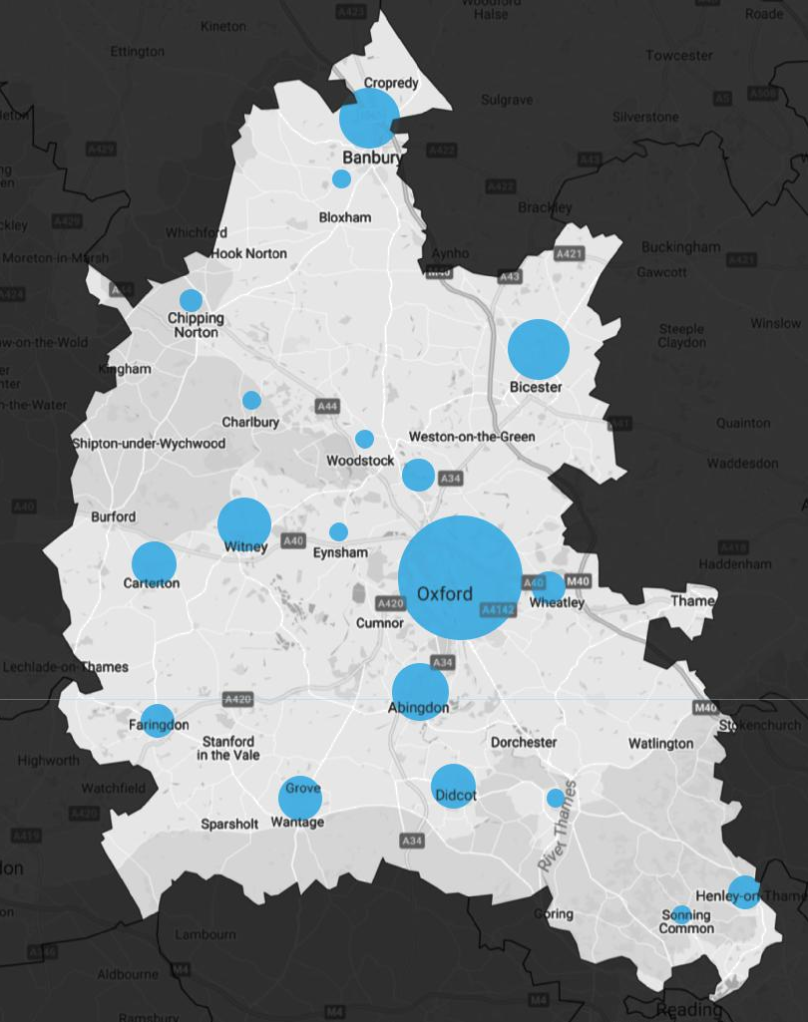
Below is a diagram of Oxfordshire, showing the most densely populated areas

Journey of a wet AMD patient
AMD can be picked up in various settings, which will lead to a referral to the Oxford Eye Hospital for diagnosis.

If diagnosed, the patient will be asked for consent to be treated with injections. These might continue for a few years. Once the patient’s vision has stabilised, injections are stopped and vision is monitored until they are then discharged from the care of the eye hospital.

After diagnosis, patients may also be referred to the low-vision clinic or local council rehabilitation services, which provide advice and devices that can help them live well with their sight loss.

At the hospital, there is a sight loss adviser, or Eye Clinic Liaison Officer (ECLO), who can provide AMD patients with emotional support or help them find services that might be helpful.

The voluntary sector is also always on hand. Charities such as the Oxfordshire Association for the Blind, the Macular Society and the RNIB (Royal National Institute of Blind People) can be of great benefit to people with AMD, offering support groups, information and a wealth of other services.

At all times, information can be given to the patient by administrative staff, clinical staff or accessed independently online or in the form of leaflets.

Below is a table showing the journey of a Wet AMD patient. The table is 5 cells across and 10 cells down.
Detection | Diagnosis | Injections & Monitoring | Monitoring | Discharge & Subsequent Care
Information
Optometrist, Consultant, Administrative, Staff and Others
Check-Up  GP | Diagnosis  OEH | Injections  OEH
Eye Test  Optometrist |  | Scans  OEH
Eye Casualty  OEH |  | Emotional Support & Info  Sight Loss Adviser (ECLO)
Chance Discovery  Other JR Clinic |  | Helpful Devices  Low-Vision Clinic
Home Visit  Fire Service |  | Emotional Support  Psychological Therapy
Rehabilitation (living skills, mobility & IT training, exercise, helpful devices and guiding people to other services)
Council Sensory Impairment team
Information & Emotional Support
Internet
Information & Emotional Support
Voluntary Organisations

The cost of treating AMD

While there is no one typical patient of AMD, we can make a reasonable assumption about the type of care someone with AMD would receive - see the list below.

The greatest cost is the injected drugs, which slow the scarring. The cost of these may come down in future but currently this is about £530 per injection.

The list of costs is as follows:

Sight test at optometrist: £25
Diagnosis at hospital: £200
Year 1 injections and scans x7.5: £5,500
Year 2 injections and scans x6: £4,400
Information and emotional support: £500
Low-vision and rehabilitation services: £500
Total: £15,525

And the cost of sight loss
We’ve covered the direct costs of AMD treatment to the NHS and social services but sight loss can have a financial impact in many other ways. The table below breaks down all costs associated with AMD treatment & sight loss in a one and ten year period in England.

 | 1 Year  Period | 10 Year  Period | % Total  Cost
Direct Health Care Cost | £266,989,271 | £2,445,126,433 | 17.72%
GP Consultations | £324,756 | £3,159,345 | 0.02%
General Ophthalmic Services | £13,484,641 | £127,556,629 | 0.92%
Hospital Care | £234,344,214 | £2,129,109,552 | 15.43%
Transport to Hospital | £444,262 | £4,321,949 | 0.03%
LV Health Service Consultation | £8,317,973 | £82,980,926 | 0.60%
Non-Ophthalmic Related Medical | £10,073,424 | £97,998,032 | 0.71%
Social and Personal Cost | £1,051,576,013 | £10,521,812,023 | 76.24%
Low-Vision Devices & Rehab | £57,213,516 | £570,336,017 | 4.13%
Paid Care (Excess) | £216,620,908 | £2,173,096,842 | 15.75%
Informal Care (Excess) | £731,244,450 | £7,315,311,299 | 53.01%
Residential Care (Excess) | £46,275,658 | £461,301,386 | 3.34%
TV Licence Allowance | £221,480 | £1,766,479 | 0.01%
Other Costs | £11,333,511 | £113,937,714 | 0.83%
Capital | £8,248,787 | £82,117,502 | 0.60%
Tax Exemption (Blind Persons) | £3,084,724 | £31,820,212 | 0.23%
Indirect Costs: Lost Productivity | £6,228,925 | £42,373,291 | 0.31%
Underemployment (Excess) | £5,899,651 | £40,121,073 | 0.29%
Absence from Work (Excess) | £329,274 | £2,252,218 | 0.02%
Deadweight Loss | £70,398,611 | £677,464,648 | 4.91%
TOTAL COST OF ILLNESS | £1,406,526,330 | £13,800,714,109

The problem
High injection costs, the growing number of people with eye conditions - including AMD - and the consequent effect on outpatient numbers at the Oxford Eye Hospital are a potent combination.

Additionally, we know that 65.8% of those referred into Oxford Eye Hospital don’t have wet AMD, which is a problem that compounds the issues above.

There were 974 new cases of AMD last year and if 75% go on to receive treatment similar to that detailed on the previous page the total expenditure (for direct costs) can be expected:

£7.6 million – Approximate direct cost throughout duration of treatment for those newly diagnosed with Wet AMD in 2016

£1 million – Cost to treat every 65 new cases of Wet AMD

Challenges facing the NHS
The problems facing the NHS are well documented. Population issues and cuts to social care are reasons why more and more people are visiting their GPs and hospitals.

Unprecedented demand is due to:
- 0.5 million annual population growth
- People living longer
- Ageing population
- Staffing crisis
- Less funding for social services

Financial pressure is due to:
- Changes in funding
- High spend on last six months of life
- Costly imports
- Medical innovation
- A weaker pound

Additionally, there is a question mark over the impact of Brexit in terms of trade tariffs on imports and European Union NHS staff.

What happens if we don’t change anything?
As numbers of people with AMD grow and services struggle to keep up or adapt, the following pattern emerges:

- Hospital services become even more stretched
- More people to make aware of symptoms and urgency of treatment
- A growing population of over 50s

This leads to:
- Delays in diagnosis
- Delays in treatment
- AMD is caught later
- AMD goes undetected

This results in more sight loss. More sight loss creates more demand and means more money is spent on health and social care. As a result, less money will be spent on proactively tackling AMD.

The STAR approach
The STAR Approach was created by health economists at the London School of Economics and the University of Oxford.

It helps people set priorities when they need to make decisions about what to change.

It does this by looking at value for money, in the following terms:
- How much it costs to fund different treatments
- How much the local population benefits from these treatments
This is calculated by:
a) Identifying how much a treatment ‘typically’ benefits one patient
b) And multiplying this by the total number of people who benefit

The key elements of the STAR process are:

PARTICIPATION
Bringing together a range of people affected by AMD care – either professionally or personally – at two workshops

TECHNICAL ANALYSIS
A specially designed tool that calculates value for money or different treatments and generates easy-to-understand diagrams

The two workshops
With most clinical areas there are a range of interventions offering different outcomes. Often there are opportunities to move funding and resources around to achieve better outcomes for local people.

The main treatment for AMD is injections, which must be provided to the patient where necessary - and it is not a case of doing more or less of these. Our discussions focussed therefore on how and where treatment/monitoring is currently delivered. While we ultimately didn’t use the technical analysis we kept the fundamental concepts of the STAR approach and adapted this to eye health pathways.

We framed our discussions using the following questions:
- What does the Oxfordshire Wet AMD pathway currently look like?
- What are the pros and cons of current AMD care in Oxfordshire?
- What might an improved service look like?

- What issues do you foresee over the next ten years?
- How can we make savings to develop services?
- What are patient attitudes toward seeing specific workforce members for different parts of their AMD care?
- What is the workforce capable of delivering now and what would require training?
- Does training currently exist or would it need to be developed?
- Patient support & education methods
- What outcomes need to be measure to show the success of a wet AMD service

The two workshops – Participants

The University of Oxford: Mara Airoldi, Director of Government Outcomes Lab
Oxfordshire CCG: Sharon Barrington, Head of Planned Care
LSE: Gwyn Bevan, Professor of Policy Analysis
The College of Optometrists: Mike Bowen, Director of Research
Thomas Pocklington Trust: Matthew Carr, Head of England Vision Strategy
Oxfordshire County Council: John Fearn-Webster, Head of Sensory Services
NECS: Richard Glover, Senior Commissioning Support Officer
Specsavers: Sundeep Rana, Community Optometrist
Karen Davies, Community Optometrist
Andrew Morgan, Community Optometrist
Frances Ramsay, Chair (Local Eye Health Network) and Optometrist
Jerry Salmon, Dispensing Optician
Anita Lightstone, Former Optometrist and Former Director of UK Vision Strategy

Oxford University Hospitals NHS Foundation Trust:
Rasmeet Chadha, Hospital Optometrist
Matthew Covill, Director of Business Planning
Stella Czypionka, Hospital Orthoptist
Susie Downes, Consultant Ophthalmologist
Carol-Anne Gourlay, Senior Finance Business Partner – Ophthalmology
Jacky Lishman, ECLO
Consuela Moorman, Consultant Ophthalmologist
Mital Shah, Medical Specialist Trainee
Helen Woolford, Quality Improvement Programme Delivery Manager

In addition to the above, four people living with wet AMD – either as a patient or carer – attended the workshops. Their names are not included here for reasons of patient confidentiality.

The two workshops – Where to focus
These three themes allow us to divide people with or without AMD into groups that can be targeted in different ways to achieve better health outcomes.

All three categories came up but the discussion mainly focussed on the first category and the measures that could be taken to ensure timely diagnosis and treatment. This is broken down in greater detail on the following two pages.

Improving detection and awareness are key in fighting AMD but making improvements in these areas relies on larger-scale changes, and were therefore less prominent workshop themes.

1. Ensure timely diagnosis & (continuous) treatment when AMD is suspected or diagnosed
- Increase capacity at OEH
- Make better use of available services and workforce
- Raise awareness of emotional support services
- Improve communication between clinicians, management, commissioners and patients

2. Improve awareness of AMD causes when AMD is preventable
- More public health campaigns highlighting the link between AMD and unhealthy living habits

3. Improve detection and awareness of symptoms when AMD is present but undetected
- Improve accessibility, frequency and uptake of sight tests
- Greater public education on AMD warning signs and the need for urgent help

The two workshops – What can we change? Part 1
All issues highlighted throughout our discussions are detailed at the end of this report, while four key improvement areas from the ‘timely diagnosis & continuous treatment’ category are broken down below.

1. Ensure timely diagnosis & (continuous) treatment:

Increase capacity at Oxford Eye Hospital
Much of the workshop conversation emphasised that staff and services at the OEH are stretched. This has an impact on the diagnosis and care of people with AMD. The group explored ways of alleviating this pressure.

Key issues
- 62% of patients don’t meet the recommended treatment time after referral
- 20% are injected within one week of first visit (recommended)
- 48% injected within two weeks of first visit
- Some patients fall out of the system

Possible factors
- 65.8% of those referred into OEH don’t have wet AMD
- Sharp increase in numbers of people coming to the eye hospital
- Flow of patients could be more efficient
- Workforce size does not meet demand
- AMD patients discharged later than they could be – leading to less capacity for those in need of treatment

Possible solutions
- Improve flow of patients at the OEH
- Reduce pressure by transferring some services out of the hospital:
a) Identify work that can be done by lower cost staff same skills
b) Stable patients monitored in the community instead of hospital
c) Fund and set up a mobile screening unit to monitor patients
d) Virtual clinic after initial consultation
e) Involve community opticians in the provision of low-vision services
f) Discharge into community optometrist

The two workshops – What can we change? Part 2

Improve communication
The workshops served as an opportunity for some participants to meet each other for the first time, despite there being significant relevance to one another’s role. While there are good links between some clinicians, communication could be improved.

This is also applicable to communication with patients, specifically in the waiting room area of OEH.

Possible solutions
- Introduce ‘roving’ helper from the voluntary sector to OEH waiting room
- Schedule regular clinician and management meetings at OEH
- Develop single information pack that provides a consistent understanding of available services for patients, clinicians and management

Raise awareness of emotional support services
AMD patients and carers felt that emotional support services could have been beneficial but were either unaware of them or had not accessed them.

Many patients are supported by their family but there are also those who are isolated and don’t have this as a resource to maintain better mental health.

There are only two part-time ECLOs in the Oxfordshire area.

Make better use of available services
The workshops revealed that there was inconsistent signposting to different services and awareness of what is available is not uniform among community and hospital staff, nor patients.

The number of services provided by the voluntary sector was not known to all and how awareness of these services is raised throughout a region is not clear.

Possible solutions to both of the above
- Full time ECLOs dedicated to AMD patients
- Better use of the voluntary sector
- Improve awareness of emotional support benefit and available services
- Develop single information pack that provides a consistent understanding of available services for patients, clinicians and management

The two workshops – Who can change
The next section detail the issues identified by the group, as well as the suggested course of action - and - who could take ownership of each identified area.

The solutions are broken down into separate categories. First, those that can be made quickly and easily, with little cost and time attached. After this, solutions are grouped in terms of the scale of impact these potential changes would have on local health outcomes:
Easy Changes: pp 21
High Impact Changes: pp 22-24
Medium & Low Impact Changes: pp 24-27

The tables are quite self-explanatory, but the key below explains them clearly. Below is a table that is consists of five columns and two rows.
Issue | Who’s affected? | Solution | Who can change this? | Impact
Long walk to use printer at OEH | OEH staff | Put printer in reception | JR management | Improve morale increase capacity

- Column one gives a short description of the issue
- Column two shows the main organisation or individual affected
- Column three shows the suggested solution. Specificity may vary, but intended as a guide to ‘doable’ actions
- Column four identifies the parties that can work together to improve the current situation
- Column five identifies the principal outcome(s) from a solution, though the ultimate objective will always be improved population health.

Easy Changes
The table below consists of five columns and six rows:

Issue | Who’s affected? | Solution | Who can change this? | Impact
Long walk to use printer at OEH | OEH staff | Printer in reception | JR management | Increase capacity  Improve morale
Patient leaflets not very visible at OEH | Patient | Better visibility  Consult patients on positioning | OEH staff | Increase use of available services  Improve health outcomes
Chief Executive doesn’t regularly visit clinic to appreciate the situation | OEH staff | Coordinate regular visits | JR management  OEH staff | Improve morale  Increase capacity
Alert system in waiting room not always effective and time wasted finding patients | Patient  OEH staff | Flashing TV screen or handheld buzzer | JR management  OEH staff | Improve morale  Increase capacity
Information for Community Optometrists on hospital eye services and low-vision services isn’t consistent | Optometrist  OEH staff | Better system for sharing info on services  Engagement with the voluntary sector | OEH staff  Low-vision  Optometrist  Voluntary sector | Increase use of available services  Improve health outcomes

High Impact Changes – Patient Outcomes
The table below consists of five columns and five rows:

Issue | Who’s affected? | Solution | Who can change this? | Impact
People fall out of the system and some who have lost central vision may become isolated with deteriorating health | Patient | Set up safety nets: Phone call month after 1st visit and month after discharge  Update GP more effectively | OEH staff  CCG | Increase capacity  Improve health outcomes  (High)
Some patients over 65 don’t have their NHS sight tests frequently enough | Patient | Evaluate current process | Optometrist  CCG | Improve health outcomes  (High)
Lack of clear discharge policy | Patient  OEH staff | Evaluate current discharge process | JR management, OEH staff, Low-vision, Optometrist, Voluntary sector, Sensory services, CCG | Increase capacity  Improve health outcomes  (High)
Poor awareness of how a healthy lifestyle can reduce likelihood of AMD | General public | Possibly comes under remit of council and local stop smoking campaigns | Optometrist  Sensory services  CCG | Improve health outcomes  (High)

High Impact Changes – Workforce / Setting
The table below consists of five columns and three rows:

Issue | Who’s affected? | Solution | Who can change this? | Impact
Pressures on staff at OEH could be relieved by additional staff and/or changing care setting | OEH staff | Additional staff: Consultants, ECLOs  Allied healthcare professionals  Use of computerised vision system  Use current facilities / van outside of JR  Rotational staff through community & hospital  Establish community based clinic for stable patients | JR management  OEH staff  CCG | Increase capacity  Improve patient / staff morale  (High)
Pressures on staff at OEH could be relieved using community resources | OEH staff | Use OCT scanners in community for monitoring  Set up virtual imaging clinic  Optometrists provide decision-making and injections | JR management  OEH staff  Optometrist  CCG | Increase capacity  (High)

High Impact Changes – Communication
The table below consists of five columns and two rows:

Issue | Who’s affected? | Solution | Who can change this? | Impact
Electronic patient record is not connected to all those who access it | Patient, OEH staff, ECLO, Low-vision clinic, Optometrist, Sensory services, Voluntary sector | Evaluate current IT process | JR management, OEH staff, Low-vision, Optometrist, Voluntary sector, Sensory services, CCG | Increase capacity  (High)

Medium & Low Impact Changes (1)
The table below consists of five columns and eight rows:

Issue | Who’s affected? | Solution | Who can change this? | Impact
Optometrists, OEH & Voluntary sector all develop very similar separate information. Advice from Community Optometrist could be better at outset | Patient  OEH staff  ECLO  Optometrist  Voluntary sector | Collaborate to develop standard info pack | OEH staff, Low-vision, Optometrist, Voluntary sector, Sensory services, CCG | Increase capacity  Improve health outcomes  (Medium)
Current link between Community Optometrist and Sensory services & ECLO could be improved | ECLO  Optometrist  Sensory services | Council to discuss low-vision training with Consultant | OEH staff  Optometrist  Sensory services | Increase use of available services  Increase capacity  Improve health outcomes  (Medium)
More thought could be given to how information can be sent digitally in future | Patients | Local health providers can discuss an existing or new strategy | JR management, OEH staff, Low-vision, Optometrist, Voluntary sector, Sensory services, CCG | Increase capacity  (Medium)
More & more difficult to contact hospital by phone – no direct line | Patient  Optometrist | A message system where patient / optometrist leaves a message and someone calls back  Additional AMD coordinator | JR management  OEH staff  CCG | Increase capacity  Improve health outcomes  (Medium)
Optometrists aren’t notified that referral has been received | OEH staff  Optometrist | Implement email receipt system | OEH staff  Optometrist  CCG | Increase capacity  (Low)
Feedback from Consultant does not always get to Community Optometrist | OEH staff  Optometrist | Best method currently is to give letter to patient but this isn’t standard practice – implement standard system | OEH staff  Optometrist | Increase capacity  (Low)
Patients not always referred to low-vision clinic when necessary | Patient | Evaluate current referral process | OEH staff  Low-vision | Increase use of available services  Increase capacity  Improve health outcomes  (Low)

Medium & Low Impact Changes (2)
The table below consists of five columns and eight rows:

Issue | Who’s affected? | Solution | Who can change this? | Impact
Patients aren’t always asked what format of communication suits them best | Patient  OEH staff | Evaluate how this can be improved | JR management, OEH staff, Low-vision, Optometrist, Voluntary sector, Sensory services, CCG | Increase capacity  (Medium)
Staff don’t have time for a cup of tea as café is too far | OEH staff | Improved management of patients | JR management  OEH staff  Voluntary sector | Improve patient / staff morale  (Medium)
Not all patients are referred to ECLO for advice & emotional support | Patient | Full-time dedicated ECLOs. ECLO not taken into another clinic. | JR management  OEH staff | Increase use of available services  Improve health outcomes  (Medium)
Not all patients are referred to voluntary sector for advice & emotional support | Patient | More signposting to 3rd sector. Use of 3rd sector to support patients with advice etc. In Berkshire, ECLO gets permission to take patient contact details to pass onto charity. | OEH staff  Low-vision Optometrist  Voluntary sector  Sensory services  CCG | Increase use of available services  Increase capacity  Improve health outcomes  (Medium)
Length of time to get injections – not always able to do this on same day | Patient  OEH staff | Improve patient flow i.e. reorganise so that scan, analysis and injection on same day  Look at opportunities to move the patient around less | JR management  OEH staff | Increase capacity  Improve patient / staff morale  (Medium)
General issues with access: parking & roadworks – can lead to missing appointments | Patient | Improved access or advice on access  Dedicated shuttle bus from park and rides | JR management | Improve patient / staff morale  (Medium)
Lack of updates in waiting room to advise on progress and delays – increased anxiety | Patient  OEH staff | A ‘roving’ person from the voluntary sector e.g. Macular Society ‘network advocates’ to reduce pressure | JR management  OEH staff  Voluntary sector  CCG | Increase capacity  (Low)

Next Steps
- Potential solutions to be discussed by workshop participants and other relevant parties:

- Discuss specific actions required for each solution
- Identify feasibility and impact of solutions
- Prioritise solutions with highest feasibility and impact ratio
- Appoint individuals or groups who are accountable for prioritised solutions
- Plan & track progress

- Maintain collaborative, cross-sector approach

Glossary
AMD: Age-related Macular Degeneration
ECLO: Eye Clinic Liaison Officer
OEH: Oxford Eye Hospital. Based at the John Radcliffe Hospital in Oxford, with a centre in Horton General Hospital.
Optometrist: Where ‘optometrist(s)’ is mentioned, this refers to those in the community. Hospital optometrists are clearly described as such.

Document Ends

RNIB Sight Loss Data Tool [Microsoft Excel spreadsheet]. Available from: http://www.rnib.org.uk/knowledge-and-research-hub-key-information-and-statistics/sight-loss-data-tool [accessed March 2017]
As above
Minassian D and Reidy A, Future Sight Loss UK 2: An epidemiological and economic model for sight loss in the decade 2010-2020. London: EpiVision and RNIB; 2009

